List of Websites

1. [<Website u'Independent studies on vaccine safety in general | Australian Vaccination-skeptics Network Inc.'>,
2. <Website u'Do you have cravings for Facebook? | The Health Information Company'>,
3. <Website u'Health Advice | Health Advice | body+soul'>,
4. <Website u"Health advice, wellbeing - Women's Health & Fitness">,
5. <Website u'Early Rise of Dengue in Bangladesh'>,
6. <Website u'Tips for preventing insect and animal bites'>,
7. <Website u'7 Health Effects of Working Too Much'>,
8. <Website u'Acne - Go Vita Health Shops'>,
9. <Website u'Dental advice for preschool children (3-5 years) - Dental Health Services Victoria'>,
10. <Website u'The Flu and you | UFS Bendigo'>,
11. <Website u'Internet games and body image | The Health Information Company'>,
12. <Website u'Top 10 Health Tips for Women'>,
13. <Website u"UFS | What's The Best Product For Head Lice?">,
14. <Website u'Trusted Health Advice | healthdirect'>,
15. <Website u'Cat Grooming - Tips & Advice For Cat Lovers | Love That Pet'>]

Website and their scores  
*Note: Apostrophe in website title caused some issues*

1. u’Trusted Health Advice | healthdirect': 4.111111111111111,
2. u’Health Advice | Health Advice | body+soul': 3.625,
3. u’Acne - Go Vita Health Shops': 3.6, u"Health advice, wellbeing - Women's Health & Fitness": 3.75,
4. u’7 Health Effects of Working Too Much': 3.6666666666666665,
5. u’Do you have cravings for Facebook? | The Health Information Company': 3.5454545454545454,
6. u’Early Rise of Dengue in Bangladesh': 3.5,
7. u’Dental advice for preschool children (3-5 years) - Dental Health Services Victoria': 4.5,
8. u’Internet games and body image | The Health Information Company': 3.75, u"UFS | What's The Best Product For Head Lice?": 3.6666666666666665,
9. u’Tips for preventing insect and animal bites': 3.2,
10. u’Independent studies on vaccine safety in general | Australian Vaccination-skeptics Network Inc.': 2.375,
11. u’Top 10 Health Tips for Women': 3.5555555555555554,
12. u’Cat Grooming - Tips & Advice For Cat Lovers | Love That Pet': 3.3529411764705883,
13. u’The Flu and you | UFS Bendigo': 4.222222222222222}

Website and their scores  
*Note: after problematic websites (and cat website) were removed from database*

1. {u’Trusted Health Advice | healthdirect': 3.5555555555555554,
2. u’Health Advice | Health Advice | body+soul': 3.625,
3. u’Acne - Go Vita Health Shops': 3.6666666666666665,
4. u’The Flu and you | UFS Bendigo': 3.3529411764705883,
5. u’7 Health Effects of Working Too Much': 3.2,
6. u’Do you have cravings for Facebook? | The Health Information Company': 3.5454545454545454,
7. u’Early Rise of Dengue in Bangladesh': 3.75,
8. u’Dental advice for preschool children (3-5 years) - Dental Health Services Victoria': 3.6,
9. u’Internet games and body image | The Health Information Company': 4.222222222222222,
10. u’Tips for preventing insect and animal bites': 3.5,
11. u’Independent studies on vaccine safety in general | Australian Vaccination-skeptics Network Inc.': 2.357142857142857,
12. u’Top 10 Health Tips for Women': 3.75}

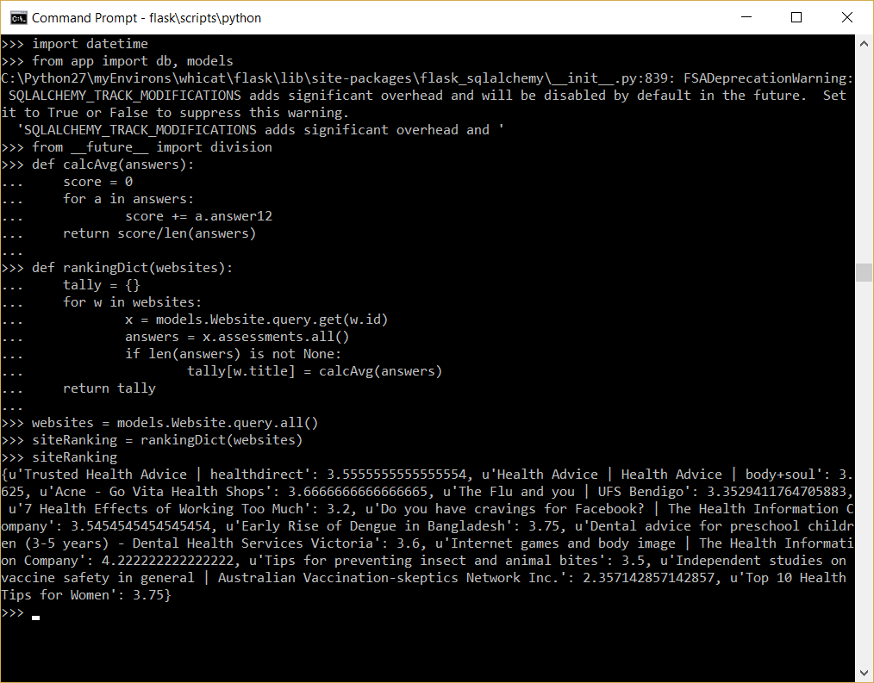

Run functions to produce dict

Two functions

1. calculate average score per website
2. create dict of website and average score

|  |  |
| --- | --- |
| Trusted Health Advice | healthdirect | 3.5555555555555554, |
| Health Advice | Health Advice | body+soul | 3.625, |
| Acne - Go Vita Health Shops | 3.6666666666666665, |
| The Flu and you | UFS Bendigo | 3.3529411764705883, |
| 7 Health Effects of Working Too Much | 3.2, |
| Do you have cravings for Facebook? | The Health Information Company | 3.5454545454545454, |
| Early Rise of Dengue in Bangladesh | 3.75, |
| Dental advice for preschool children (3-5 years) - Dental Health Services Victoria | 3.6, |
| Internet games and body image | The Health Information Company | 4.222222222222222, |
| Tips for preventing insect and animal bites | 3.5, |
| Independent studies on vaccine safety in general | Australian Vaccination-skeptics Network Inc. | 2.357142857142857, |
| Top 10 Health Tips for Women | 3.75 |